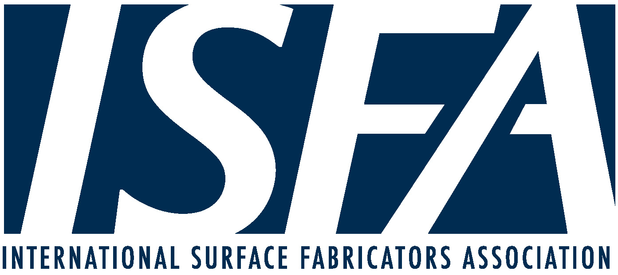

Employees That Do Not Want to Come Back to Work:
How It Impacts Your PPP loan.

Are your employees resisting coming back to work?

According to a recent study, 54% of U.S. employees are worried about exposure to COVID-19 at their job. In addition, with the extra $600 that an employee can collect under the Coronavirus Aid, Relief, and Economic Security (CARES) Act, an employee can collect $1,000 a week or more of unemployment benefits. This may be more than their regular pay, yet another reason to be disinterested in returning to work.

Unfortunately, employees refusing to come back to work can impact the amount of a Payroll Protection Program (“PPP”) loan that is forgiven. To maximize the amount of the loan forgiven, employers must meet three requirements:

- 75% of the PPP loan must be used on payroll costs;

- Each employee’s pay during the 8 weeks must not be reduced by more than 25% of the employee’s pay during the most recent full quarter during which the employee was employed; and

- The average number of full-time employee equivalents paid during the 8-week must be the same as the average number of full-time employee equivalents paid between February 15, 2019 and June 30, 2019 OR January 1, 2020 and February 29, 2020. Employers get to choose the comparison period. If you pay fewer employees during the 8-week period, the amount forgiven will be proportionately reduced. To determine the number of full-time employee equivalents you include part timers based on the amount they worked (e.g., five part-timer employees working one 8-hour shift a day equals one full-time employee).

This week the Small Business Administration (“SBA”) issued new guidance that addressed this issue. The SBA stated that it will exclude “laid-off employees whom the borrower offered to rehire (for the same salary/wages and same number of hours) from the CARES Act’s loan forgiveness reduction calculation.”

To have these employees excluded, the employer must make “a good faith, written offer of rehire, and the employee’s rejection of that offer must be documented.” To document the refusal, an employer can send an email to the employee verifying their rejection of the rehire offer. Be sure to put both the written offer and the email confirming the rejection in the employees file; they will be needed when applying to have the PPP loan forgiven.

It is unclear how this exclusion will be applied. It appears that the calculations in item 2 (maintaining each employee’s pay level) and item 3 (comparing the number of employees) will not be applied in determining the amount of the loan to be forgiven for employees that refuse to return to work. It is not clear, however, if and how it will apply the 75% rule in item 1. Based on the primary purpose of the PPP loans—to maintain payroll—it is likely that 75% of the loan will still have to be used on payroll costs, whether or not there are the same number of employees.

With the rapid pace at which laws, rules and orders are being issued, ISFA and its association peers are working to keep members informed and updated regarding their opportunities and obligations during the COVID-19 crisis. The Association will also continue to provide important information that may impact members.

Notice: We thank our friends at WFCA for sharing their guidance and collaboration in the creation of this document. The information contained in this update is abridged from legislation, court decisions, and administrative rulings, and should not be construed as legal advice or opinion, and is not a substitute for the advice of counsel.

Issued May 8, 2020

