PPP (Paycheck Protection Program) Application Checklist

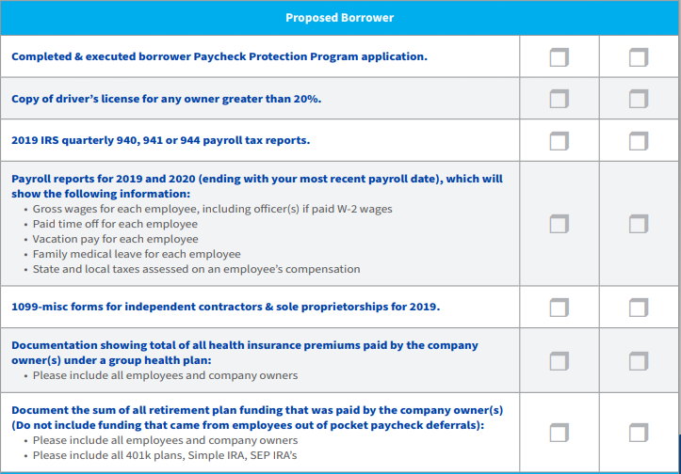
*Please note* Additional documentation may be required/requested by your Lender. All SBA loans are subject to eligibility, program requirements, and program availability.
Visit https://www.sba.gov/funding-programs/loans/coronavirus-relief-options/paycheck-protection-program-ppp for more information. Loans subject to credit application and approval.

